Contents

PRACTICAL 1: REPORT ON LIFE SKILL WORKSHOP 5

LIFE SKILL WORKSHOP 5

Introduction: 5

Day1: 5

Session1 5

Session2 5

Day2: 5

Session1 5

Session2 6

Day3: 6

Session1 6

Session2 6

PRACTICAL NO 2: GREEN COMPUTING 7

PRACTICAL NO 3: FREE SOFTWARE AND OPEN SOFTWARE SOURCES 9

# 

# PRACTICAL 1: REPORT ON LIFE SKILL WORKSHOP

# LIFE SKILL WORKSHOP

# Introduction:

The Life Skill Workshop is organized by Nagindas Kandwala College for the students in IT/CS department on 25th to 27th November 2019. The Dr Sujata Singhi conducted three day Workshop in the college Auditorium to improve the life skills and attitude towards society.

# Day1:

## Session1

On the 1st section is started with the speech of principal, wise-Principal and the host Dr.Sujata Singhi Has given the important of life Skill. And start the session at 10:15 and they first make group of 8 students. They select there group name and explored at stage. The task is given for group to identify some product and market them on stage.

## Session2

The 2nd session of the day the speech of how to overcome fear, where different student spoke about what are the greatest fear and host help to overcome that fear. Then the workshop followed by an energetic dance “follow the leader” then the deep topic discussed by a host is “Gratitude” .this topic was discussed by host by sharing her true story which was happened to her and then she given the student the exercise to be performed and then the host made a visualization session and then day was ended after that.

# Day2:

## Session1

The second day was started by the host asking the student how they did the practice which was assigned to them and them the student shared their thoughts with everyone who were present in the class. Then a booklet was distributed to everyone with a pink sheet was that sheet was the declaration sheet. Student were asked to fill the booklet. Then there was the energetic dance ‘follow the leader’ and the many students were called to stage to dance.

## Session2

The second session of the day began with an energetic dance ‘follow the leader’. After which all the student were assigned into different group and were given an activity per group in which they were to make a spaceship attractive in a comic fashion and had a great fun sharing each group’s experience with other group. Then there was the energetic dance ‘follow the leader’ and then many student were called to stage to dance.

# Day3:

## Session1

The first session of the day started with an energetic dance ‘follow the leader’ .Each and every group of student were assigned with a group activity to make individual family poster to depict the love and gratitude between the family members and also to depict our creativity. This activity was brainstorming with different intellectual concept and creativity.

## Session2

The last session of the seminar and the day was concluded by thanks giving to the honorary speaker Dr.Sujata singhi and the respected Faculties of Nagindas Khandwala collage who made this possible and successful and the student were distributed with certificate and in conclusion of the seminar all danced to different song and at last with a group photograph.

# PRACTICAL NO 2: GREEN COMPUTING

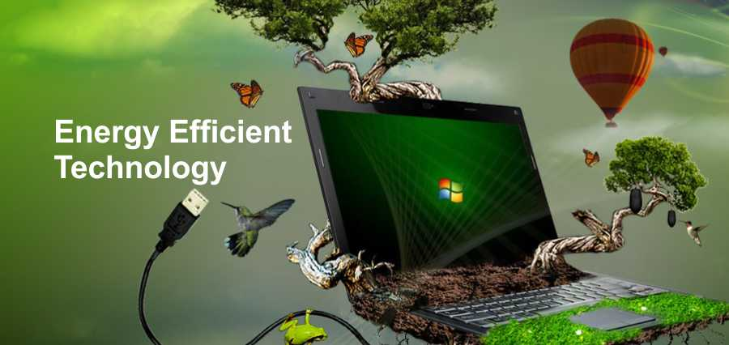

Figure :green computing

**Defination:**

Green computing, green ICT as per International Federation of Global & Green ICT "IFGICT", green IT, or ICT sustainability, is the study and practice of environmently sustainable computing or IT.

The goals of green computing are similar to green chemistry reduce the use of hazardous materials, maximize energy efficiency during the product's lifetime, the recyclability or biodegradability of defunct products and factory waste. Green computing is important for all classes of systems, ranging from handheld systems[[1]](https://en.wikipedia.org/wiki/Green_computing#cite_note-1) to large-scale data centers. Many corporate IT departments have green computing initiatives to reduce the environmental effect of their IT operations.[[3]](https://en.wikipedia.org/wiki/Green_computing#cite_note-3)

Whitelabel ITSolutions maintains the goal to leave as minimal of an eco-footprint as possible, while continuously making our data center as “green friendly” as possible through green computing.

**What is the meaning of green computing?**

Green computing is the environmentally responsible and eco-friendly use of computers and their resources. In broader terms, it is also defined as the study of designing, manufacturing/engineering, using and disposing of computing devices in a way that reduces their environmental impact.

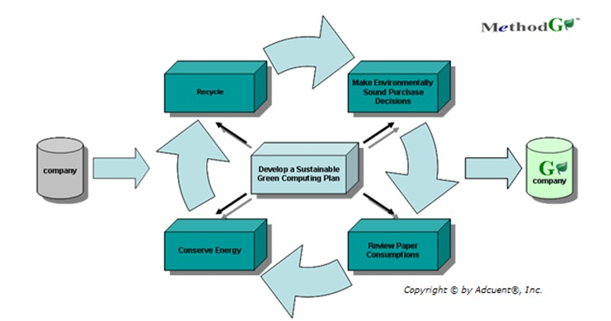

Figure :green computing diagram

**What does green computing mean for Whitelabel ITSolutions?**

Whitelabel ITSolutions is able to be eco-friendly by our companies’ use of premium energy efficient ENERGY STAR servers (Dell, HP) that consume considerably less power than regular models, joining a list of data centers that are able to offer clients “greener” product options.

**How green computing conserves power.**

Energy star server consumed 54% less power than older model servers. Servers that earn the energy star will, on average, be about 30% more energy-efficient than standard servers. In addition to using less energy themselves, energy star-qualified servers substantially reduce cooling loads in data centers. A general rule of thumb suggests that one watt saved by a server has the added benefit of saving one to two watts of cooling power. It’s important to note that these power savings come with a substantial increase in performance – at 50% utilization.

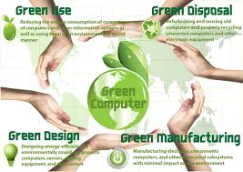

Figure

# PRACTICAL NO 3: FREE SOFTWARE AND OPEN SOFTWARE SOURCES

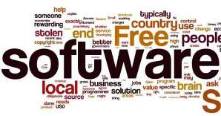

Figure

Defination

"FLOSS", "FOSS", and "Free and Open-source" redirect here. For hardware, see [Open-source hardware](https://en.wikipedia.org/wiki/Open-source_hardware). For other uses, see [Foss (disambiguation)](https://en.wikipedia.org/wiki/Foss_(disambiguation)).

A screenshot of Free and Open-source software (FOSS): [Linux Mint](https://en.wikipedia.org/wiki/Linux_Mint) running the [Xfce](https://en.wikipedia.org/wiki/Xfce) [desktop environment](https://en.wikipedia.org/wiki/Desktop_environment), [Firefox](https://en.wikipedia.org/wiki/Firefox), a calculator program, the built-in calendar, [Vim](https://en.wikipedia.org/wiki/Vim_(text_editor)), [GIMP](https://en.wikipedia.org/wiki/GIMP), and [VLC media player](https://en.wikipedia.org/wiki/VLC_media_player). Free and open-source software is [software](https://en.wikipedia.org/wiki/Software) that can be classified as both [free software](https://en.wikipedia.org/wiki/Free_software) and [open-source software](https://en.wikipedia.org/wiki/Open-source_software). That is, anyone is [freely licensed](https://en.wikipedia.org/wiki/Free_software_license) to use, copy, study, and change the software in any way, and the [source code](https://en.wikipedia.org/wiki/Source_code) is openly shared so that people are encouraged to voluntarily improve the design of the software. This is in contrast to [proprietary software](https://en.wikipedia.org/wiki/Proprietary_software), where the software is under restrictive [copyright](https://en.wikipedia.org/wiki/Copyright) [licensing](https://en.wikipedia.org/wiki/Licensing) and the source code is usually hidden from the users.

FOSS maintains the software user's civil liberty rights (see the [Four Essential Freedoms](https://en.wikipedia.org/wiki/Free_and_open-source_software#Four_essential_freedoms_of_Free_Software), below). Other benefits of using foss can include decreased software costs, increased [security](https://en.wikipedia.org/wiki/Security_(computing)) and stability (especially in regard to [malware](https://en.wikipedia.org/wiki/Malware)), protecting [privacy](https://en.wikipedia.org/wiki/Privacy), education, and giving users more control over their own hardware. Free and open-source operating systems such as [Linux](https://en.wikipedia.org/wiki/Linux) and descendants of [BSD](https://en.wikipedia.org/wiki/BSD) are widely utilized today, powering millions of [servers](https://en.wikipedia.org/wiki/Server_(computing)), [desktops](https://en.wikipedia.org/wiki/Desktop_computer), smartphones (e.g. [Android](https://en.wikipedia.org/wiki/Android_(operating_system))), and other devices. [Free-software licenses](https://en.wikipedia.org/wiki/Free-software_license) and [open-source licenses](https://en.wikipedia.org/wiki/Open-source_license) are used by [many software packages](https://en.wikipedia.org/wiki/List_of_open-source_software_packages). The [free-software movement](https://en.wikipedia.org/wiki/Free-software_movement) and the [open-source software movement](https://en.wikipedia.org/wiki/Open-source_software_movement) are [online social movements](https://en.wikipedia.org/wiki/Online_social_movement) behind widespread production and adoption of foss.

FOSS benefits over proprietary software

Personal control, customizability and freedom

Users of FOSS benefit from the [Four Essential Freedoms](https://en.wikipedia.org/wiki/Free_software#Definition_and_the_Four_Freedoms) to make unrestricted use of, and to study, copy, modify, and redistribute such software with or without modification. If they would like to change the functionality of software they can bring about changes to the code and, if they wish, distribute such modified versions of the software or often − depending on the software's [decision making model](https://en.wikipedia.org/wiki/Group_decision-making) and its other users − even push or request such changes to be made via updates to the original software.

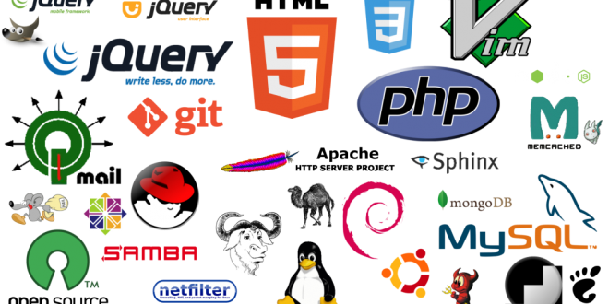

figure

Privacy and security

|  |  |
| --- | --- |
| FREE SOFTWARES | OPEN SOURCE SOFTWARES |
| Freedom to run program for any purpose. | It has distribution of license. |
| Freedom to study about program. | Availability of Source code. |
| Freedom to distribute copies of software. | Free distribution. |
| Freedom to modify/improve program and release improvments to public | Integrity of Authors Source code. |

Manufacturers of proprietary, closed-source software are sometimes pressured to building in [backdoors](https://en.wikipedia.org/wiki/Backdoor_(computing)) or other covert, undesired features into their software. Instead of having to trust software vendors, users of FOSS can inspect and verify the source code themselves and can put trust on a community of volunteers and users. As proprietary code is typically hidden from public view, only the vendors themselves and hackers may be aware of any [vulnerabilities](https://en.wikipedia.org/wiki/Vulnerability_(computing)) in them while FOSS involves as many people as possible for exposing bugs quickly.

DIFFERENCE BETWEEN FREE AND OPEN-SOURCE SOFTWERES

Figure

Low costs or no costs

FOSS is often free of charge although donations are often encouraged. This also allows users to better test and compare software.

Quality, collaboration and efficiency

Foss allows for better collaboration among various parties and individuals with the goal of developing the most efficient software for its users or use-cases while proprietary software is typically [meant to generate profits](https://en.wikipedia.org/wiki/Profit_motive). Furthermore, in many cases more organizations and individuals contribute to such projects than to proprietary software. It has been shown that technical superiority is typically the primary reason why companies choose open source software.

Drawbacks compared to proprietary software

Security and user-support

According to [Linus's law](https://en.wikipedia.org/wiki/Linus%27s_law) the more people who can see and test a set of code, the more likely any flaws will be caught and fixed quickly. However, this does not guarantee a high level of participation. Having a grouping of full-time professionals behind a commercial product can in some cases be superior to foss. Furthermore, publicized source code might make it easier for hackers to find vulnerabilities in it and write exploits. This however assumes that such malicious hackers are more effective than [white hat hackers](https://en.wikipedia.org/wiki/White_hat_(computing)) which [responsibly disclose](https://en.wikipedia.org/wiki/Responsible_disclosure) or help fix the vulnerabilities, that no code leaks or [exfiltrations](https://en.wikipedia.org/wiki/Data_breach) occur and that [reverse engineering](https://en.wikipedia.org/wiki/Reverse_engineering) of proprietary code is a hindrance of significance for malicious hackers.

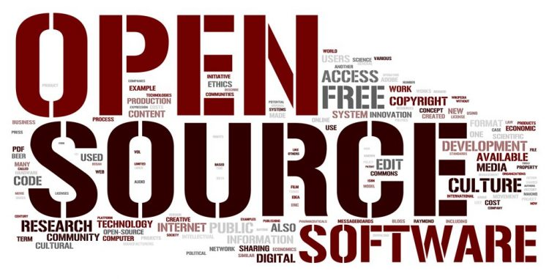

figure

4. **LIST OF FIGURES**

Figure 1:green computing 4

Figure 2:green computing diagram 5

Figure 3 5

Figure 4 6

figure 5 7

Figure 6 7

figure 7 8